# Guide: How to import project into Eclipse

## # step 1.

Download Eclipse IDE for Java EE Developers (ex. http://www.eclipse.org/downloads/packages/eclipse-ide-java-ee-developers/marsr). Install it.

## # step 2.

Install gradle plugin for Eclipse. Go to Eclipse Marketplace (Help menu) and search for gradle plugin Buildship Gradle Integration 2.0. Install it and do restart for eclipse.

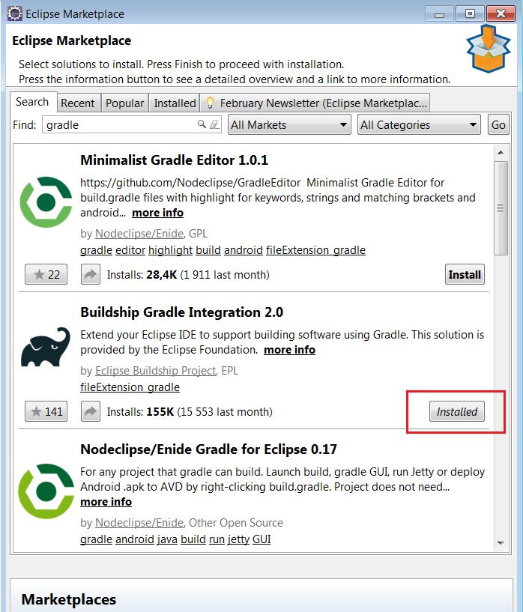

# stap 3.

Import project from existiting gradle project. Go to File -> Import and search for Existing Gradle Project under gradle folder and follow installation guide. (But previously you may need to download gradle package from [https://services.gradle.org/distributions choose 3.4](https://services.gradle.org/distributions%20choose%203.4) bin archive)

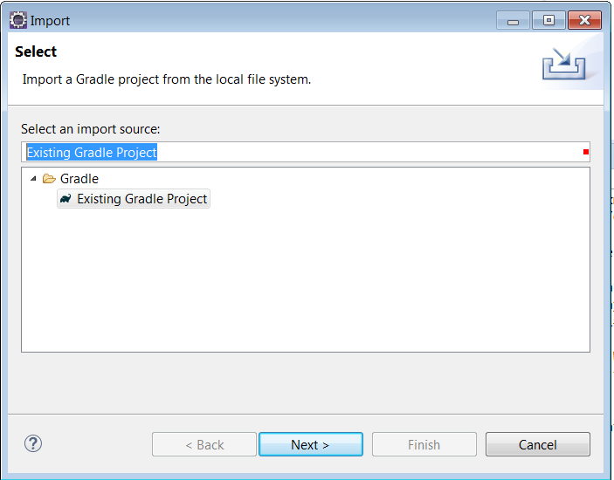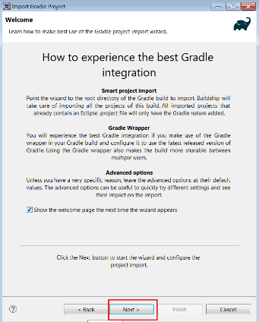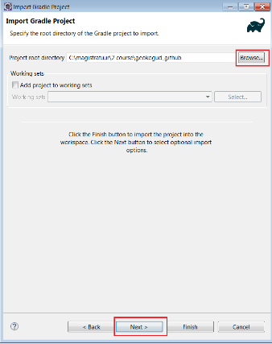

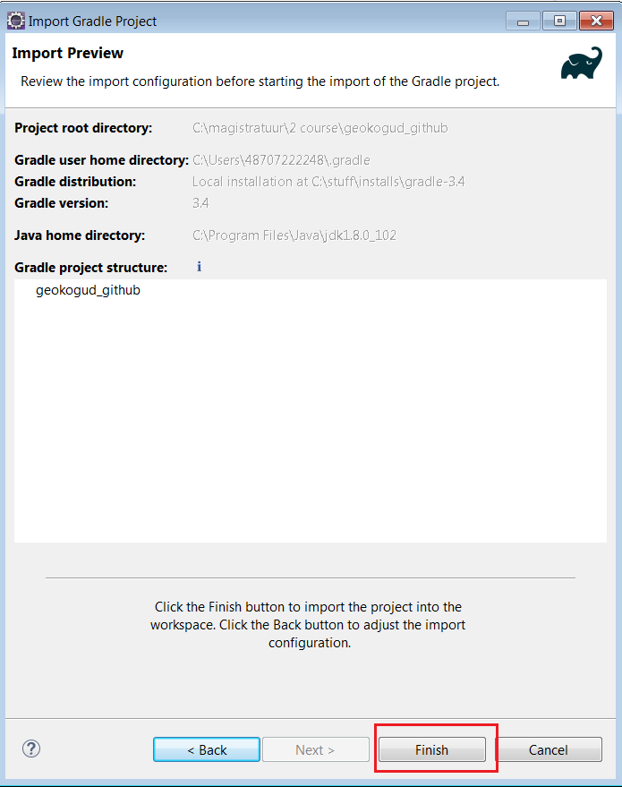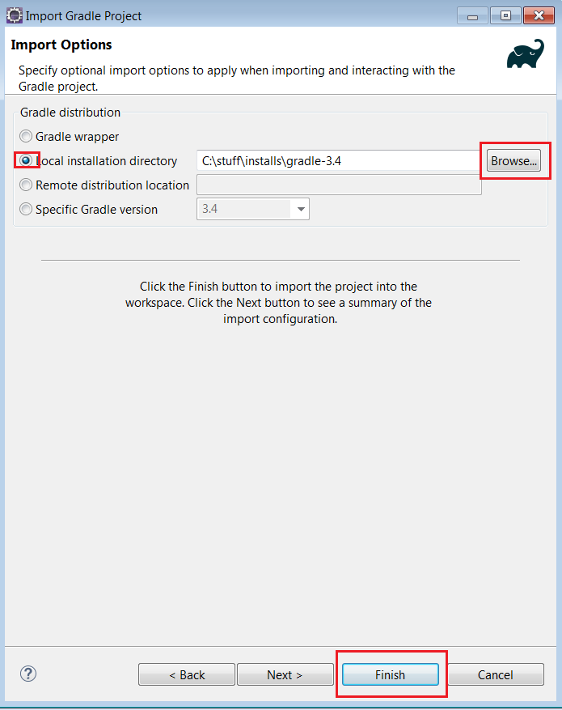

# step4.

Run gradle project. Under gradle tasks(right corner of Eclipse window) open application folder and double click bootRun. Wait until you will see in console Started App. Now project is running on localhost:8080